Interview Preparation for Priyanka Agarwal - Sr. Manager, CDM Role at Pliant Therapeutics

Research the Company and Role
- Pliant Therapeutics: Focus on developing novel therapeutics for fibrotic diseases.
- Company Values: Commitment to innovative science and addressing unmet medical needs.
- Therapeutic Approach: Focus on integrin biology and TGF-β modulation.
- Location: South San Francisco; recognized as a "Best Place to Work."
- Key Links:
  - Briana Ault-Davis LinkedIn Profile
  - Pliant Therapeutics LinkedIn
  - Pliant Therapeutics Website
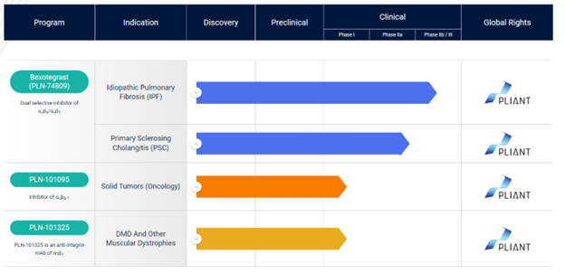
- Action Steps:
  - Review Pliant’s products, services, and recent news to align your insights.
  - Study the job description thoroughly and map your experience with the key requirements.
  - Prepare 2-3 thoughtful questions about the role, team, and the company for the interview.

Review Your Experience
- Experience: 13+ years in Clinical Data Management across all phases of clinical trials.
- Therapeutic Expertise: Respiratory, Cardiology, Oncology, and Infectious Diseases.
- Vendor Management: Extensive experience overseeing data management vendors and managing CRF development and validation.
- Regulatory Compliance: Strong adherence to ICH/GCP guidelines and regulatory requirements.
- EDC Proficiency: Expert user of Rave, Clinical One, Inform, and Oracle Clinical.
- Leadership: Proven record in mentoring teams, process optimization, and overseeing data management activities across trials.

Prepare STAR Stories
- SOP Development at Invivyd: Created and maintained SOPs while ensuring regulatory compliance across multiple trials.
- Oversight of Vendors at IAVI: Managed DM-related tasks, ensuring smooth collaboration with CROs, Clinical Operations, and Biostatistics teams.
- Mentoring at Fred Hutchinson Cancer Research Center: Led training programs to develop new data management talent.
- Database Development at Invivyd: Collaborated with cross-functional teams to create CRF and ensure database setup for effective clinical data capture.
- Process Optimization at PAREXEL: Implemented data validation and cleaning processes that streamlined data quality and database lock timelines.

Highlight Your Strengths
- Therapeutic Experience: Extensive knowledge in oncology, respiratory, cardiology, and infectious diseases.
- Vendor and CRO Management: Strong experience in managing external vendors and aligning their outputs with organizational goals.
- Technical Expertise: Proficient in EDC systems, including Medidata Rave, Oracle Clinical, and Clinical One.
- Leadership and Mentoring: Proven ability to lead teams and mentor junior staff in data management.
- Compliance and Process Improvements: Strong understanding of regulatory guidelines with a proven track record of implementing process improvements.

Prepare for Common CDM Interview Questions
- How do you ensure data quality and integrity throughout a clinical trial?
- Describe your approach to managing CRO and vendor relationships.
- How do you manage conflicting priorities or tight timelines?
- What strategies do you use for effective cross-functional collaboration?
- How do you stay current with industry trends and regulatory requirements in CDM?
- Describe a challenging data management issue you encountered and how you resolved it.
- How do you approach training and mentoring team members?
- What process improvements have you implemented in previous roles?
- How do you ensure consistency in data collection across multiple sites?
- Describe your experience with risk-based monitoring approaches.

Questions to Ask the Interviewer
- What are the unique CDM challenges in managing trials for fibrotic diseases?
- How does Pliant’s CDM team collaborate with other functions to support integrin biology and TGF-β modulation research?
- What opportunities exist for implementing innovative CDM approaches in Pliant's clinical trials?
- How does Pliant’s company culture support cross-functional collaboration in clinical development?
- What are the key priorities for this role in supporting Pliant’s late-stage clinical programs?

Additional Tips
- Review any publicly available information on Pliant’s clinical trial designs for fibrotic diseases.
- Be prepared to discuss your experience with relevant therapeutic areas, especially those related to fibrosis.
- Highlight any experience with EDC systems specifically used in fibrosis or rare disease trials.
- Be ready to discuss your approach to managing CDM for complex, long-term trials, typical in fibrotic disease research.
- Prepare examples of how you’ve applied evolving CDM best practices to challenging therapeutic areas.

Closing the Interview
- Reiterate Interest: Emphasize your interest in contributing to Pliant’s mission of addressing unmet needs in fibrotic diseases.
- Summarize Experience: Align your extensive CDM experience, especially in complex therapeutic areas, with Pliant’s needs.
- Emphasize Adaptability: Highlight your ability to quickly adapt and bring best practices from diverse trial experiences to support Pliant’s growing clinical programs.

